Visakha Container Freight Station (VCT-CFS)

Standard Operating Policy and Procedures

CFS Operations
Introduction

A standard operating policy & procedure (SOPP) is a set of step-by-step activities compiled by an organization to help workers carry out complex as well as standard routine operations. SOPPs help to achieve efficiency, quality output and uniformity of performance while contributing to efforts that lead to process excellence.
This SOPP aims to achieve the following objectives:
1. Act as a guide and reference document to stakeholders at all levels of the organization
2. Clearly communicate activities and help to achieve consistency in operational procedures
3. Create accountability by assigning responsibilities at each stage of the lifecycle
4. Aid governance by documenting auditable processes and detailing control elements at each stage of the lifecycle

What is the Lifecycle and Process Tree?

Each SOPP follows the process tree hierarchy and covers a specific entire process.
- A process represents logical grouping of sub processes and provides detail at functional level
- A sub process represents grouping of similar activities
- An activity lists down specific tasks that have/are measurable, time bound, associated risks, mitigating controls and defined owners
The entire business lifecycle consists of several processes. An SOPP is tasked with the coverage of all sub process and activities applicable to a particular process.

Who are the Stakeholders for this SOPP?

This stakeholders for this SOPP shall primarily be activity owners and business units.
1. Activity owners (operating units) – Activity owners shall use this SOPP as a reference document while performing their activities daily.
2. Business units – Business units shall use the SOPP as a repository of all activities across the lifecycle. This will aid in identifying process improvement opportunities.

Who will use this SOPP?

This SOPP shall be used by stakeholders across the entire organization. Most notable shall be the following:
1. Risk and Governance units – Risk and Governance units shall reference the SOPP to review existing controls and test their
2. Auditors – Auditors shall use this SOPP to check adherence to defined processes and standards. The SOPP shall help them identify any deviations to defined processes
How do you read the SOPP?
To read this SOPP, it is essential to understand the process lifecycle and its coverage. This SOPP is documented in a chronological order in line with the sequence of activities performed by activity owners. Therefore, it should be read as such.
This SOPP also provides references to various organization level policies, checklists, systems, reports etc. These have been appropriately referenced at applicable activities and attached as Annexures to this SOPP.
Each activity has an activity owner assigned to it. An activity also has the following references against it:
- Performer – Person who will execute the activity.
- Frequency – Each activity has defined period.
- Template – Reference to any template (If Any)
- System / Manual reference – Each activity is performed either manually or rooted through system.

Organization structure

The organization structure defined in the SOPP is the structure defined at the functional level. 'Activity owners' are defined are those who are responsible for performing the activity. 'Business Owners' are defined as those who have oversight and ultimate ownership for the activities.
The 'roles and responsibilities' table in the SOPP lists down the 'business owners' and provides details on key activities they are responsible for. The list of 'business owners' shall form the organization structure for the SOPP and mega process.

Rules for this SOP

- This SOPP shall be reviewed on annual basis.
- Any changes in the SOPP will be approved by Terminal Head And Then Updated By CFS Head/QHSE/Operations HOD
Document review and approval

Revision history

Version | Created By | Document Approved By | Date Approved | Revision
V1 | XX | CFS Head /Terminal Head | XX | XX
SOPP Number | 1
Applicable Entities
  Entity Type | Entity Name
  Container Freight Station (CFS) | - Visakha Container Freight Station
Process Owner | Terminal/Branch Head
IT Applications
  Entity Name | System
  Visakha Container Freight Station | I-Portman (TOS) , SAP Hana
Guidelines / Policy reference
SOPP Cross References

Contents

CFS Operations 1
Abbreviations and Definitions 13
Organization Structure 16
Process Flow - Overview 17
Export Operations 18
Export Cargo Receiving 18
➢ Export Container Delivery 19
- Export Cargo Stuffing 20
- Factory Stuffed Container – Receiving 21
- Factory Stuffed Container - Delivery 22
Import Operations 23
➢ Import Container Receiving 23
➢ De Stuff of Material 24
➢ De Stuff - Container 25
➢ Import Cargo Delivery 26
➢ Delivery – Import Container 27
➢ FDS Delivery 28
Key Process Activities 29
1.Gate In Process 29
2.Container Survey 32
3.Yard Operations 33
4.Export Operations - Export Cargo Receiving 35
4.1.Export Operations - Export Container Delivery 36
4.2.Export Operations – Export Cargo Stuffing 38
4.3.Export Operations - Factory Stuffed Container 40
4.4.Export Operations – Factory Stuffed Container 41
5.Import Operations – Import Container Receiving 43
5.1Import – De-Stuffing of Import material 45
5.2.Import Operations - De Stuffing of Import container 46
5.3.Import Operations – Delivery of Import Cargo 47
5.4.Import Operations – Delivery of Import Container 48
5.5.Import Operations – FDS Delivery 49
6.Warehouse Operations 50
7.Other Operations -Empty Container 52
8.Other Operations - Reefer 56
9.Other Operations - Container Handling -OOG (Out of Gauge) 59
10.Gate Out Operations 62
Symbols/ legends used in flowcharts 64

Abbreviations and Definitions
Abbreviations | Details
BD | Business Development
BOE | Bill of entry
CEO | Chief Executive Officer
CFS | Container Freight Station
CHA | Customs House Agent
CLP | Container Load Plan
COO | Chief Operating Officer
DC | Delivery Challan
DGM/ AGM | Deputy/ Assistant General Manager
DO | Delivery Order
DOA | Delegation of Authority
EC | Executive Committee
EIR | Equipment Interchange Report
ETA | Estimated Time of Arrival
ETV | External Transport Vehicle
EWE/EWS | Export Warehouse Executive/Surveyor
F&A | Finance and Accounts
FDS | Factory De Stuffing
GM | General Manager
GR /IR | Goods Receipt / Invoice Receipt
HO | Head Office
HOD | Head of Department
IGM | Import General Manifest
IPORTMAN | TOS System
ITV | Internal transfer Vehicle
JO | Job Order
KPI | Key Performance Indicators

Definitions:

- Company/ Entity: Any references/ mention of “entity” or “company” in the SOP refers to “J M Baxi Group.”
- Import General Manifest (IGM): An Import General Manifest (IGM) is a legal document that lists the details of a shipment of goods entering a country. It is a mandatory document that is submitted to customs before the goods arrive. The carrier or their authorized agent prepares the IGM.
- Bill of Entry (BOE): Bill of Entry (BoE) is a legal document filed by importers or customs agents to facilitate the customs clearance process for imported goods. This document is essential for ensuring that all applicable taxes and duties are paid, and the goods comply with the importing country's regulations.
- Bill of Lading (BL): A Bill of Lading is a legal document issued by a carrier (or their agent) to acknowledge the receipt of cargo for shipment.
- Customs Housing Agents (CHA): A customs house agent (CHA) is a licensed professional who helps importers and exporters with customs clearance. They function as a liaison between traders and customs authorities.
- Out of Charge: A customs status that indicates that goods have been cleared for import
- Transshipment Port Terminal Service Agreement (TPTSA): This type of agreement would typically cover:
- Handling charges
- Storage terms
- Liability
- Documentation processes
- Responsibilities of the shipping line and terminal operator
- Let Export Order (LEO): is the final clearance given by Indian Customs that allows goods to be exported out of the country. It signifies that - Customs has completed all formalities and approves the export of the cargo. Once LEO is granted, the cargo can be loaded onto the vessel for export.
- Carting Permission: is the authorization given by Customs or CFS authorities to allow the movement (or "carting") of export cargo into the CFS for processing and further shipment. It permits the exporter or their agent to bring goods physically into the CFS for Examination, Stuffing into containers and Customs clearance (eventually leading to LEO – Let Export Order)
- Factory Stuffing (FS): Refers to a procedure where the export cargo is directly stuffed (loaded) into the container at the exporter’s factory premises, rather than at a CFS or port.
- Release Order (RO):is an authorization document issued by the CFS operator that allows the consignee to take delivery of imported goods after all customs and terminal formalities are completed.
Executive Summary
Container Freight Station (CFS) Standard Operating Procedures (SOP) document outlines the processes, policies, and best practices that govern the efficient, safe, and compliant operation of CFS. It is designed to ensure that all CFS activities, including cargo handling, logistics, safety protocols, and customer service, are carried out consistently and in line with industry standards and regulatory requirements.
This SOP aims to optimize operational efficiency by defining clear workflows and responsibilities, minimizing operational risks, and enhancing customer satisfaction through streamlined processes. Key components of the SOP include:
- Cargo Handling Procedures: Guidelines for the receipt, storage, and dispatch of cargo, ensuring accurate and timely processing.
- Equipment Maintenance and Safety: Procedures for the upkeep of port equipment and safety systems, ensuring operational readiness and risk mitigation.
- Logistics and Documentation: Standardized methods for managing the flow of goods and proper documentation to ensure legal compliance and smooth supply chain management.

Organization Structure:

CEO

Terminal Head -VCTPL

CFS Head
Manager - Operations

Executive - Operations

Process Flow - Overview
Container Survey
Yard Operations
Warehouse Operations ( Export and Import)
Start
End

Key Activities Flow
Gate out
Gate In
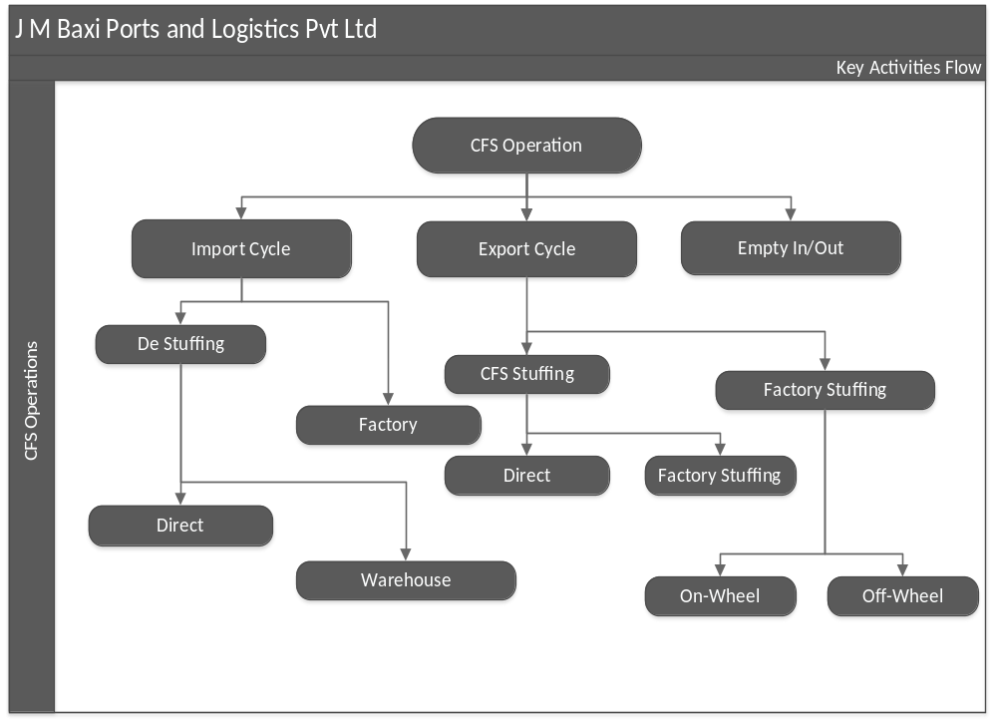

Process Flow

Export Operations

Export Cargo Receiving

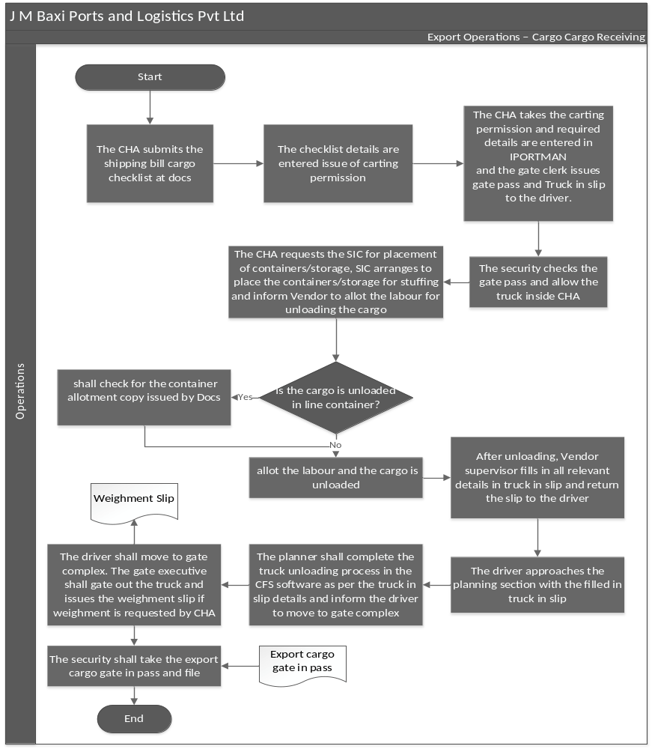

Process Flow

Export Operations

Export Container Delivery

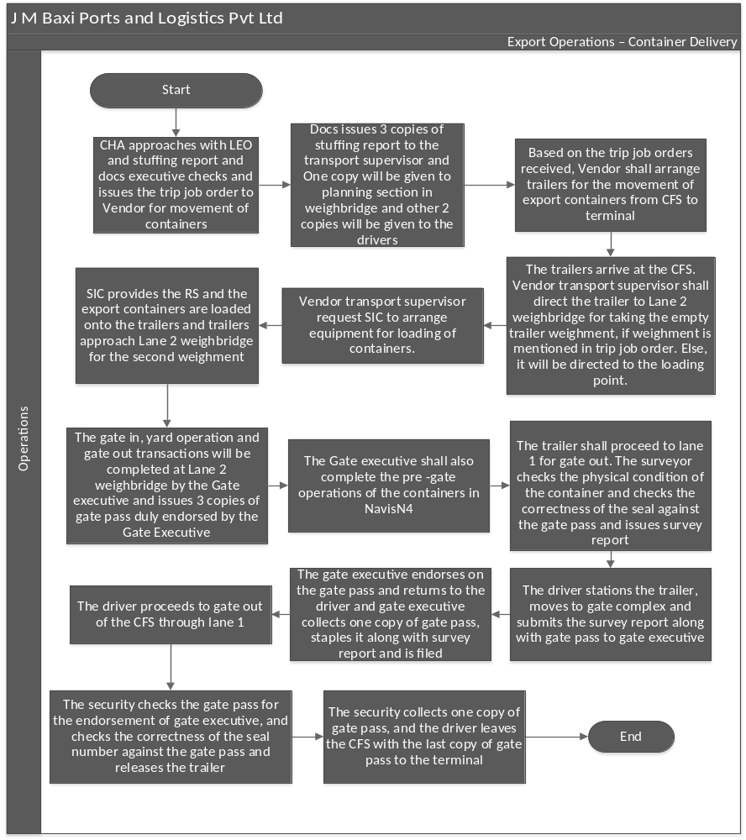

Process Flow

Export Operations

Export Cargo Stuffing

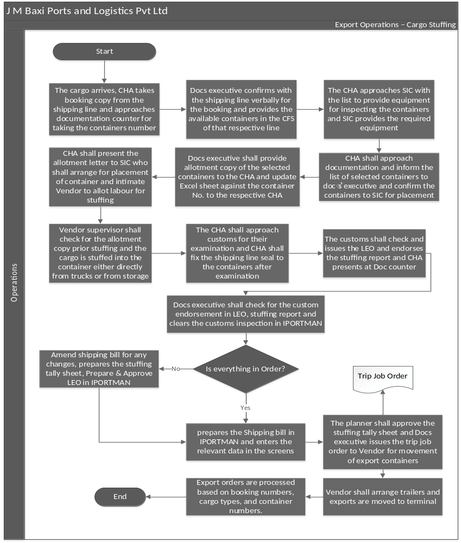

Process Flow

Export Operations

Factory Stuffed Container – Receiving

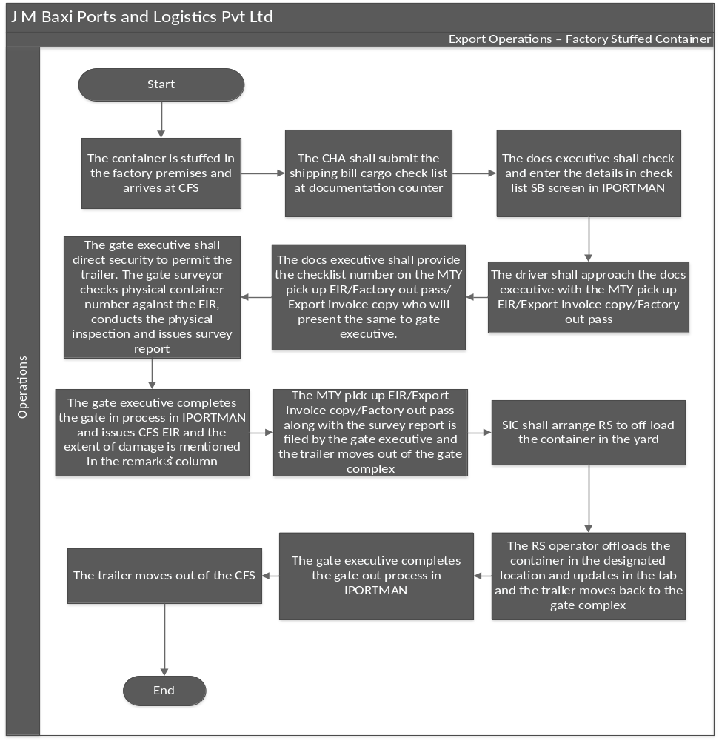

Process Flow

Export Operations

Factory Stuffed Container - Delivery

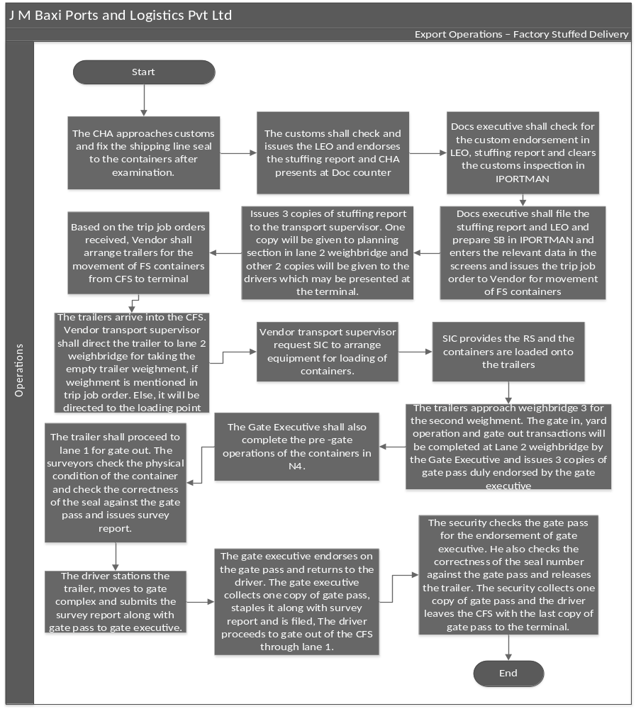

Process Flow

Import Operations

Import Container Receiving

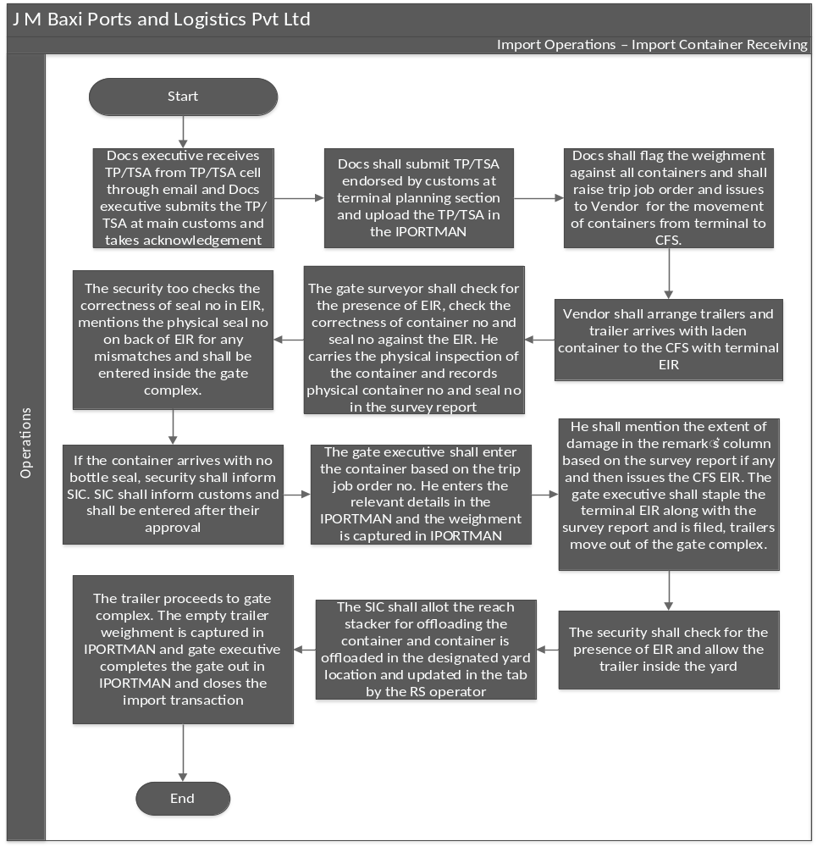

Process Flow

Import Operations

De Stuff of Material

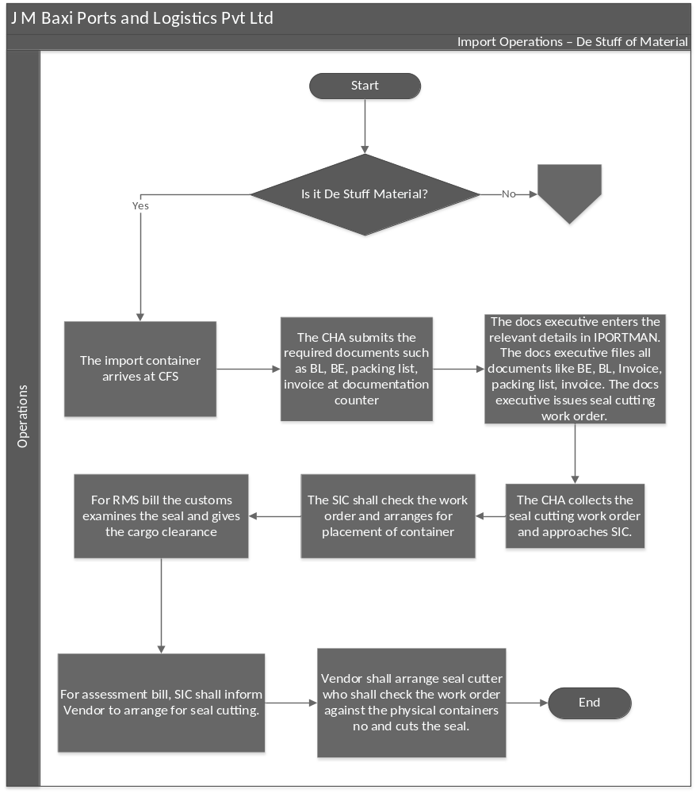

Process Flow

Import Operations

De Stuff - Container
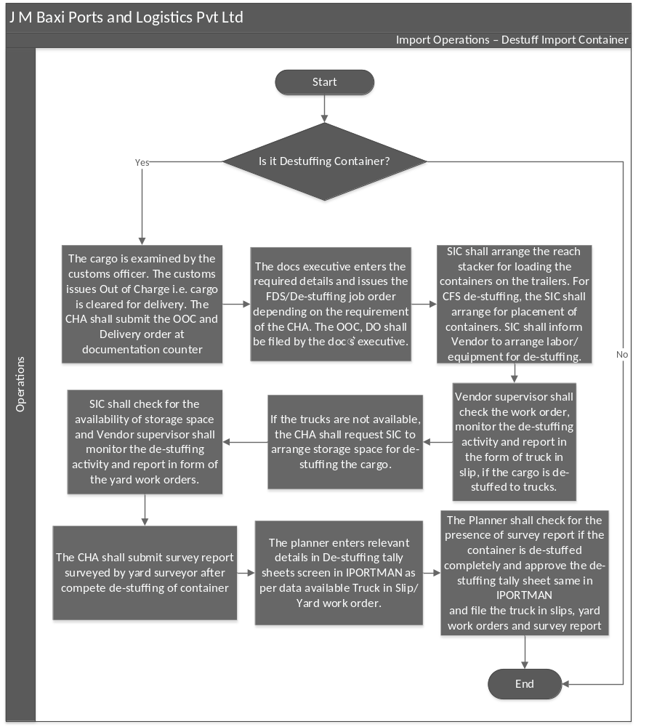

Process Flow

Import Operations

Import Cargo Delivery

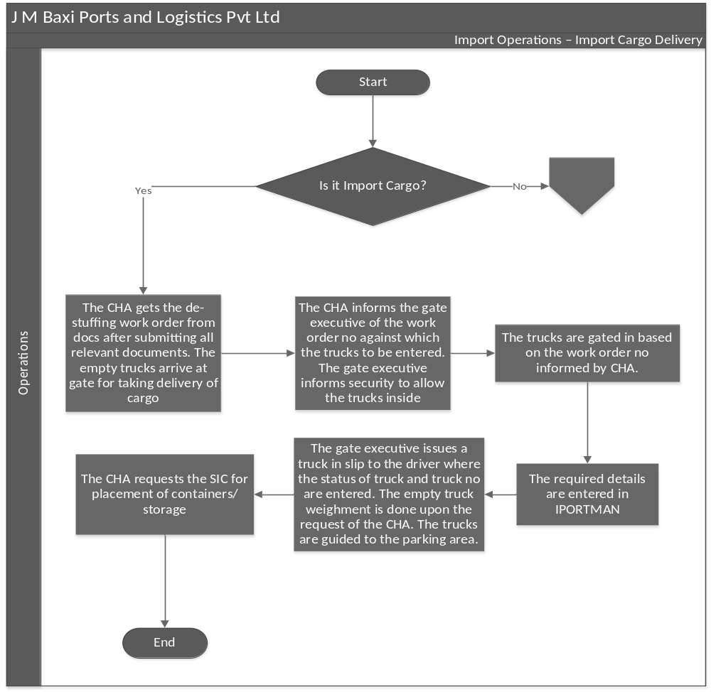

Process Flow

Import Operations

Delivery – Import Container

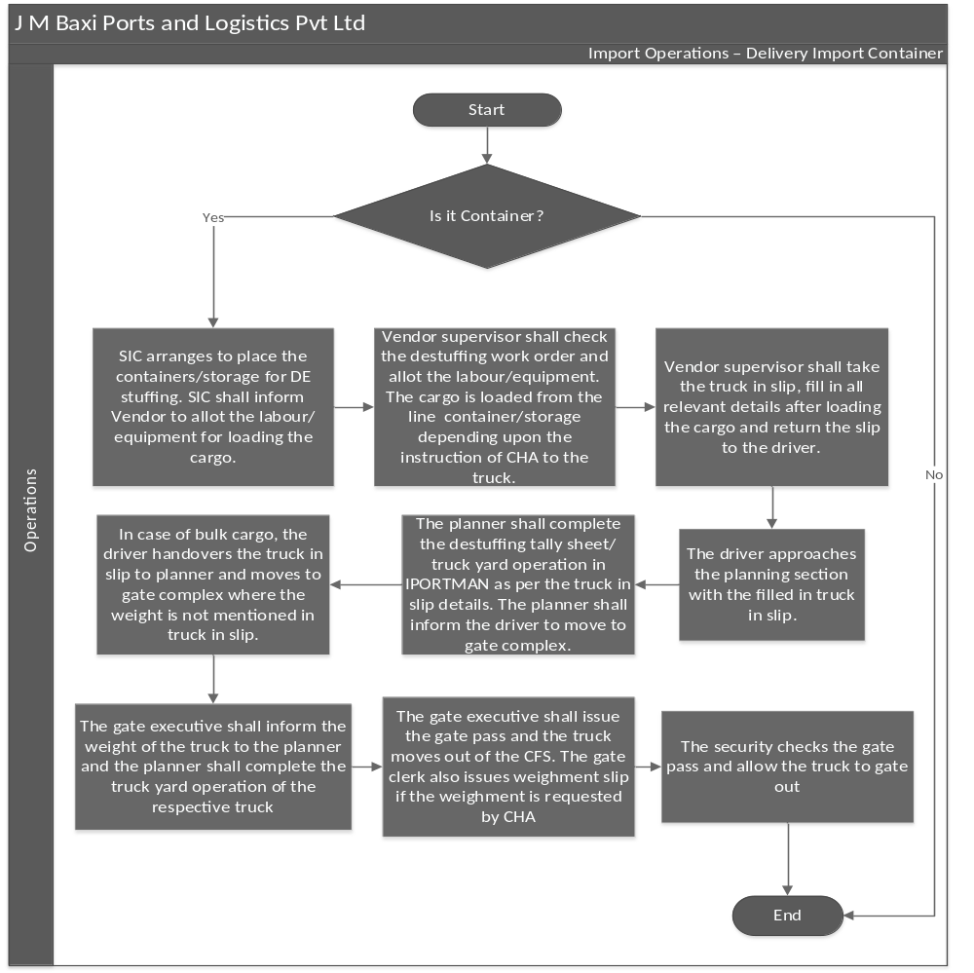

Process Flow

Import Operations

FDS Delivery

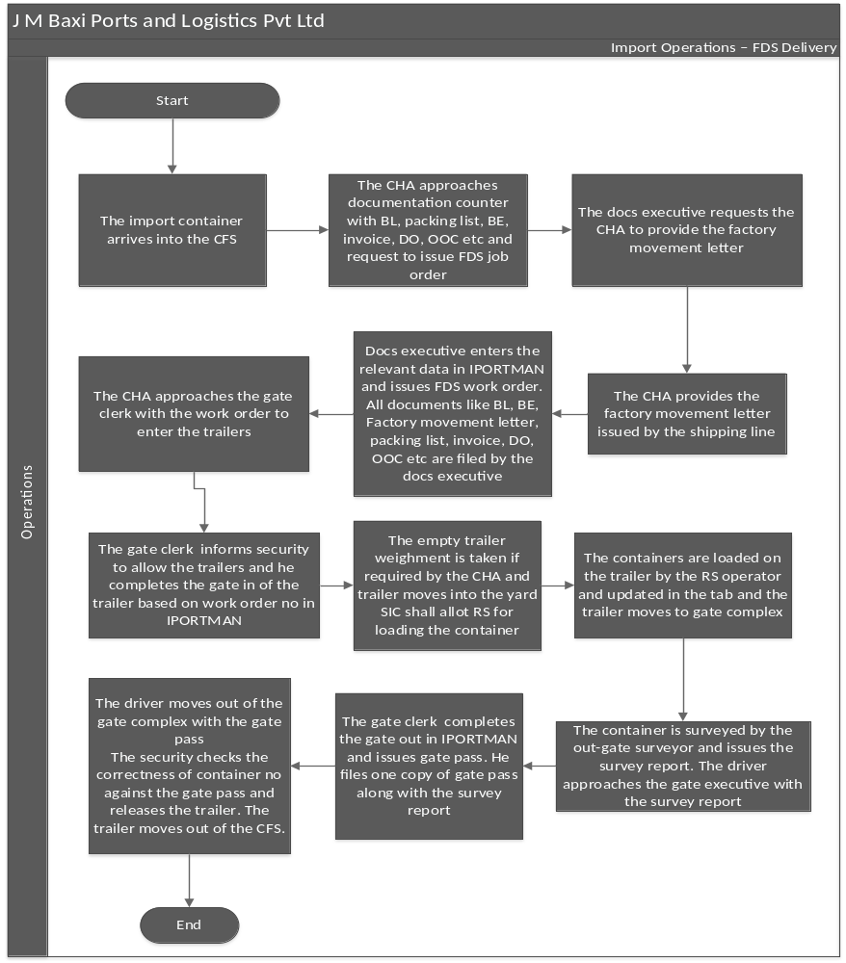

Key Process Activities

Gate In Process

Process Narrative
Description | Responsibility | Accountability | Frequency | System / Manual
1.1 Verification Of Documents  The transporter/driver approaches the In Gate Surveyor by presenting the authorized Job Orders (JO) and, if applicable, any weighment-related tax invoices. All JOs must be issued and authorized by the documentation. Each specific activity must have a corresponding and valid JO.  Upon arrival, In Gate Surveyor conducts a physical inspection of the containers before they enter the gate. The surveyor verifies that all relevant details visible on the container align with those listed on the JO. The following details must be recorded on the Gate Pass:  - Arrival time  - Trailer numbers  - Transport company name  - Seal number  The Gate In Surveyor must verify the following details:  • Container number  • Size of the container  • Type of container  • Validity of the Job Order (date and time) | Gate Executive | HOD – Yard Operations | As and when | Manual
1.2 Container Survey  - If the container is damaged, the Gate Surveyor should follow these steps:  - Create Damage Survey Report and take photographs.  - Submit the Damage Survey Report and photos to the SIC, Yard Operations, and Customer Service (CS) teams.  - Permit movement (entry) only after receiving written approval from the CS Team or SIC. | In Gate Surveyor | HOD – Yard Operations | As and when | Manual
1.3 Verification by Security  In Gate Security carries out the following activities:  - Record the vehicle's arrival time, vehicle number, transport company name, driver's license number, driver's name, and mobile number in the Gate Register.  - Scan all e-seals affixed to export-loaded containers.  - Acknowledge the Gate Pass, ensuring all relevant details are recorded in the Gate Register.  - Conduct an alcohol test on the driver and enter the results in the register.  - If the alcohol test is negative, hand over the photo pass the driver and permit the vehicle's entry. The alcohol reading should not exceed 0.050%. If the reading is higher, the vehicle should be put on hold. The vehicle will only be allowed entry once the alcohol reading is below the prescribed limit. | Gate Security | HOD – Yard Operations | As and when | Manual
1.4 Updation in TOS  Gate Executive performs the following activities:  - Update the Job Order (JO) details in the Terminal Operating System (TOS).  - Enter the TOS gate-in date and time and sign the Gate Pass.  - Handover the signed Gate Pass to Gate Security for further processing.  - Arrange for weighment if the CHA requests  - Internally verify whether the container/cargo-related vehicles should be allowed entry. | Gate Executive | HOD – Yard Operations | As and when | Manual
1.5 Offloading of Container  Executive - Yard determines the specific yard or location where the container, upon arrival through the gate, needs to be offloaded. Both the vehicle and the Reach Stacker (RS) should be positioned accordingly. Reach Stacker (RS) Operator reaches the specified yard as per given directions and safely offload / load containers from / to the trailer. | Executive - Yard | HOD – Yard Operations | As and when | Manual
1.7 Container Gate-out  Out Gate Security performs the following activities:  - Physically cross-check the container/cargo details with the Gate Pass.  - Inspect the trailer cabins to ensure there is no pilferage.  - Inform the Gate Executive to arrange weighment for the empty trailer, if required.  - Seals affixed on containers need to be cross checked and accordingly informed to Gate Executive | Out Gate Security | HOD – Yard Operations | As and when | Manual
1.8 Container Survey  Out Gate Surveyor performs the following activities:  - Conduct a physical survey of containers loaded on the trailers.  - Update all gate-out records in the Terminal Operating System (TOS) and Gate Registers. In case of any damage, prepare and submit Damage Survey Report to all concerned and handover a copy to driver (if required) | Out Gate Surveyor | HOD – Yard Operations | As and when | Manual

Container Survey

Process Narrative
Description | Responsibility | Accountability | Frequency | System / Manual
2.1 Survey at Container Entry  Once the container arrives at the gate (rail/road) via trailer, it is surveyed by the Gate Surveyor, and the seal is checked by the security staff.  The trailer is directed to the respective yard for offloading. | In Gate Surveyor | HOD – Operations | As and when | Manual
2.2 Survey at Container Exit  Once the trailer (ETV) arrives inside the yard with a valid Job Order (JO) and the specified container location mentioned on it, the vehicle proceeds to the respective yard for loading.  The nominated RS in the yard loads the specified container mentioned on the JO under the supervision of the yard surveyor.  After the container is loaded, the vehicle can proceed with the gate-out process. | Out Gate Surveyor | HOD – Operations | As and when | Manual

Yard Operations

Process Narrative
Description | Responsibility | Accountability | Frequency | System / Manual
3.1 Offloading of Container  The Executive - Yard carries out the following activities:  - Check the Job Order (JO) and arrange for the offloading/loading of containers as per the requirements.  - Guide Reach Stacker (RS) operators to ensure safe handling of containers.  - Organize separate offloading for both laden and empty containers, following the yard plan.  - Avoid tower stacking and ensure containers are stacked according to the designated slots. | Executive - Yard | HOD – Yard Operations | As and when | Manual
3.2 Reach Stacker (RS) Operations  Reach Stacker (RS) Operators carry out the following activities:  - Position all operators in the yard according to the deployment plan shared by the SIC.  - Ensure safe handling in the yard by stacking containers according to the nominated slots and following handling instructions provided in advance.  - Avoid tower stacking and ensure corner-to-corner stacking of containers.  - Follow all safety rules while handling containers.  - Work under the guidance of Yard Surveyors for safe and proper handling of containers.  - Ensure that the reverse camera and sensors are in working condition while operating the Reach Stacker in the yard.  - Maintain sufficient aisle space for the safe handling of containers. | Reach Stacker (RS) Operators | HOD – Yard Operations | As and when | Manual
3.3 ITV Operations  ITV Operators carry out the following activities:  - Position all drivers in the yard according to the deployment plan shared by the SIC.  - Ensure safe driving in the yard by maintaining the speed limit as per safety guidelines.  - Avoid driving beneath suspended loads in the yard and follow all safety rules while driving. | ITV Operators | HOD – Yard Operations | As and when | Manual
3.4 Yard Operations  Executive - Yard oversees and manages all yard activities, following the instructions provided by the Shift In-Charge (SIC). They ensure that offloading is carried out according to the yard plan.  Executive - Yard is also responsible for arranging regular physical inventories of containers to prevent discrepancies later. Additionally, they assist with internal shifting tasks, such as moving containers for repair, survey, or shifting empty containers for the stuffing of export cargo. | Executive - Yard | HOD – Yard Operations | As and when | Manual

4. Export Operations - Export Cargo Receiving

Process Narrative
Description | Performed By | Accountability | Frequency | System / Manual
4.1 Cargo Receiving  - The CHA submits the shipping bill cargo checklist at docs.  - The checklist details are entered and docs issues carting permission.  - The CHA takes the carting permission no which is used for entering the cargo trucks and the cargo trucks arrive at gate. The trucks are gated in based on the carting permission no informed by CHA.  - The required details are entered in IPORTMAN and the Gate Executive issues gate pass to the driver  - The Gate Executive also issues a truck in slip to the driver where the status of truck and truck no are entered, and gate executive takes the weighment of the truck as per the instructions.  - The security checks the gate pass and allow the truck inside CHA and the trucks are guided to the parking area.  - The CHA requests the SIC for placement of containers/storage, SIC arranges to place the containers/storage for stuffing.  - SIC shall inform Vendor to allot the labour for unloading the cargo.  - Vendor supervisor shall allot the labour and the cargo is unloaded in storage or line container depending upon the instruction of CHA. If cargo is unloaded in the line container, he shall check for the container allotment copy issued by Docs.  - Vendor supervisor shall take the truck in slip, fill in all relevant details after unloading the cargo and return the slip to the driver.  - The driver approaches the planning section with the filled in truck in slip.  - The planner shall complete the truck unloading process in the CFS software as per the truck in slip details and the planner shall inform the driver to move to gate complex.  - The driver shall move to gate complex. The gate executive shall gate out the truck and issues the weighment slip if weighment is requested by CHA.  - The security shall take the export cargo gate in pass and file | Export Executive - Warehouse | HOD - Operations /CFS Head | As & When | Manual

4.1. Export Operations - Export Container Delivery

Process Narrative
Description | Performed By | Accountability | Frequency | System / Manual
4.1.1 Export Container Delivery  - Docs also issues three copies of stuffing report to the transport supervisor and One copy will be given to planning section in lane 2 weighbridge and other two copies will be given to the drivers which may be presented at the terminal.  - Based on the trip job orders received, Vendor shall arrange trailers for the movement of export containers from CFS to terminal.  - The trailers arrive at the CFS. Vendor transport supervisor shall direct the trailer to weighbridge three for taking the empty trailer weighment if weighment is mentioned in trip job order. Else, it will be directed to the loading point.  - Vendor transport supervisor request SIC to arrange equipment for loading of containers.  - SIC provides the RS and the export containers are loaded onto the trailers and trailers approach lane 2 weighbridge for the second weighment.  - The gate in, yard operation and gate out transactions will be completed at lane 2 weighbridge by the gate executive and issues three copies of gate pass duly endorsed by the gate executive.  - The gate executive shall also complete the pre -gate operations of the containers in NavisN4.  - The trailer shall proceed to lane 2 weighbridge for gate out. The surveyor checks the physical condition of the container and checks the correctness of the seal against the gate pass and issues survey report.  - The driver stations the trailer, moves to gate complex and submits the survey report along with gate pass to gate executive.  - The gate executive endorses on the gate pass and returns to the driver and gate executive collects one copy of gate pass, staples it along with survey report and is filed.  - The driver proceeds to gate out of the CFS through lane 2 weighbridge.  - The security checks the gate pass for the endorsement of planner and gate executive and checks the correctness of the seal number against the gate pass and releases the trailer.  - The security collects one copy of gate pass, and the driver leaves the CFS with the last copy of gate pass to the terminal. | Export Executive - Warehouse | HOD - Operations /CFS Head | As & When | Manual

4.2. Export Operations – Export Cargo Stuffing

Process Narrative
Description | Performed By | Accountability | Frequency | System / Manual
4.2.1 Export Cargo Stuffing  - The cargo arrives at the CFS and CHA takes booking copy from the shipping line for stuffing of containers.  - The CHA approaches documentation counter for taking the containers number.  - The CHA approaches documentation counter for taking the containers, the docs executive confirms with the shipping line verbally for the booking and provides the available containers in the CFS of that respective line.  - The CHA approaches SIC with the list to provide equipment for inspecting the containers.  - SIC shall provide the required equipment for the same.  - The CHA shall check and confirm the containers to SIC for placement and CHA shall approach documentation and inform the list of selected containers to doc’s executive.  - Docs executive shall provide allotment copy of the selected containers to the CHA. He shall update the same in Excel sheet against the container No. to the respective CHA  - CHA shall present the allotment letter to SIC who shall arrange for placement of container.  - SIC shall intimate Vendor to allot labour for stuffing.  - Vendor supervisor shall check for the allotment copy prior stuffing and the cargo is stuffed into the container either directly from trucks or from storage.  - The CHA shall approach customs for their examination and CHA shall fix the shipping line seal to the containers after examination.  - The customs shall check and issues the LEO. Also endorses the stuffing report and CHA approaches documentation counter with LEO and stuffing report.  - Docs executive shall check for the custom endorsement in LEO, stuffing report and clears the customs inspection in IPORTMAN  - Docs executive prepares the Shipping bill in IPORTMAN and enters the relevant data in the screens. He shall amend the shipping bill for any changes, prepares the stuffing tally sheet, prepares, and approves the LEO in IPORTMAN.  - The planner shall approve the stuffing tally sheet.  - Docs executive issues the trip job order to Vendor for movement of export containers from CFS to terminal.  - Vendor shall arrange trailers and exports are moved to terminal.  - Export orders are processed based on booking numbers, cargo types, and container numbers. | Export Executive - Warehouse | HOD - Operations /CFS Head | As & When | Manual

4.3 Export Operations - Factory Stuffed Container

Process Narrative

Description | Performed By | Accountability | Frequency | System / Manual
4.3.1 Factory Stuffed Container Receiving  - The container is stuffed in the factory premises and arrives at CFS  - The CHA shall submit the shipping bill cargo check list at documentation counter  - The docs executive shall check and enter the details in check list SB screen in IPORTMAN  - The driver shall approach the docs executive with the MTY pick up EIR/Export Invoice copy/Factory out pass  - The docs executive shall provide the checklist number on the MTY pick up EIR/Factory out pass/Export invoice copy who will present the same to gate executive.  - The gate executive shall direct security to permit the trailer. The gate surveyor checks physical container number against the EIR, conducts the physical inspection and issues survey report  - The gate executive completes the gate in process in IPORTMAN and issues CFS EIR.  - The MTY pick up EIR/Export invoice copy/Factory out pass along with the survey report is filed by the gate executive and the trailer moves out of the gate complex  - The security checks for the presence of CFS EIR and allow the trailer to move into the yard  - SIC shall arrange RS to off load the container in the yard  - The RS operator offloads the container in the designated location and updates in the tab and the trailer moves back to the gate complex  - The gate executive completes the gate out process in IPORTMAN  - The trailer moves out of the CFS | Export Executive - Warehouse | HOD - Operations /CFS Head | As & When | Manual

4.4. Export Operations – Factory Stuffed Container

Process Narrative
Description | Performed By | Accountability | Frequency | System / Manual
4.4.1 Factory Stuffed Container  - The CHA approaches customs for cargo examination  - The CHA shall fix the shipping line seal to the containers after examination.  - The customs shall check and issues the LEO. Also endorses the stuffing report.  - CHA approaches documentation counter with LEO and stuffing report.  - Docs executive shall check for the custom endorsement in LEO, stuffing report and clears the customs inspection, work order in IPORTMAN.  - Docs executive shall file the stuffing report and LEO.  - Docs executive prepares the Shipping bill in IPORTMAN and enters the relevant data in the screens. He shall amend the shipping bill for any changes.  - Docs executive completes LEO in IPORTMAN  - Docs executive issues the trip job order to SVT for movement of Factory stuffing (FS) containers from CFS to terminal.  - Docs executive also issues three copies of stuffing report to the transport supervisor. One copy will be given to gate executive in lane 2 weighbridge and other two copies will be given to the drivers which may be presented at the terminal.  - Based on the trip job orders received, Vendor shall arrange trailers for the movement of FS containers from CFS to terminal.  - The trailers arrive at the CFS. Vendor transport supervisor shall direct the trailer lane 2 weighbridge for taking the empty trailer weighment if weighment is mentioned in trip job order. Else, it will be directed to the loading point  - Vendor transport supervisor request SIC to arrange equipment for loading of containers.  - SIC provides the Reach stacker (RS) and the containers are loaded onto the trailers.  - The trailers approach lane 2 weighbridge for the second weighment.  - The gate in, yard operation and gate out transactions will be completed at lane 2 weighbridge by the gate executive and issues three copies of gate pass duly endorsed by the gate executive.  - The gate executive shall also complete the pre -gate operations of the containers in N4.  - The trailer shall proceed for gate out. The surveyors check the physical condition of the container and issues survey report.  - The gate executive endorses on the gate pass and returns to the driver. The gate executive collects one copy of gate pass, staples it along with survey report and is filed.  - The driver proceeds to gate out of the CFS through lane 2 weighbridge.  - The security checks the gate pass for the endorsement of gate executive. He also checks the correctness of the seal number against the gate pass and releases the trailer. The security collects one copy of gate pass and the driver leaves the CFS with the last copy of gate pass to the terminal. | Export Executive - Warehouse | HOD - Operations /CFS Head | As & When | Manual

5. Import Operations – Import Container Receiving

Process Narrative
Description | Performed By | Accountability | Frequency | System / Manual
5. Import Container Receiving  - Docs executive receives TP/TSA from TP/TSA cell through email and Docs executive submits the TP/TSA at main customs and takes acknowledgement.  - Docs shall submit TP/TSA endorsed by customs at terminal planning section and upload the TP/TSA in the IPORTMAN.  - Docs shall flag the weighment against all containers and shall raise trip job order and issues to Vendor for the movement of containers from terminal to CFS. Vendor shall arrange trailers for the same.  - The trailer arrives with laden container to the CFS with terminal EIR. The gate surveyor shall check for the presence of EIR, check the correctness of container no and seal no against the EIR. He carries the physical inspection of the container and records physical container no and seal no in the survey report.  - The security too checks the correctness of seal no in EIR, mentions the physical seal no on back of EIR for any mismatches and shall be entered inside the gate complex.  - If any mismatches, the gate executive shall mention the physical seal no in the remark’s column.  - If the container arrives with no bottle seal, security shall inform SIC. SIC shall inform customs and shall be entered after their approval.  - The gate executive shall enter the container based on the trip job order no. He enters the relevant details in the IPORTMAN and the weighment is captured in IPORTMAN  - He shall mention the extent of damage in the remark’s column based on the survey report if any and then issues the CFS EIR. The gate executive shall staple the terminal EIR along with the survey report and is filed, trailers move out of the gate complex.  - The security shall check for the presence of EIR and allow the trailer inside the yard.  - The SIC shall allot the reach stacker for offloading the container and container is offloaded in the designated yard location and updated in the tab by the RS operator.  - The trailer proceeds to gate complex. The empty trailer weighment is captured in IPORTMAN and gate executive completes the gate out in IPORTMAN and closes the import transaction. | Import Executive - Warehouse | HOD – Operations/  CFS Head | As & When | Manual

5. 1 Import – De-Stuffing of Import material

Process Narrative
Description | Performed By | Accountability | Frequency | System / Manual
5.1 De-Stuffing of Import material  - The import container arrives at CFS.  - The CHA submits the required documents such as BL, BE, packing list, invoice at documentation counter.  - The docs executive enters the relevant details in IPORTMAN. The docs executive files all documents like BE, BL, packing list, invoice. The docs executive issues seal cutting work order.  - The CHA collects the seal cutting work order and approaches SIC.  - The SIC shall check the work order and arranges for placement of container.  - For RMS bill the customs examines the seal and gives the cargo clearance.  - For assessment bill, SIC shall inform Vendor to arrange for seal cutting.  - Vendor shall arrange seal cutter who shall check the work order against the physical containers no and cuts the seal.  - Import Executive arranges LCL container de-stuffing in warehouse on arrival as per IGM. In case of LCL - Destuffing is done prior customs examining cargo. Customer wise examining is done before release. | Import Executive - Warehouse | HOD – Operations/  CFS Head | As & When | Manual

5.2. Import Operations - De Stuffing of Import container

Process Narrative

Description | Performed By | Accountability | Frequency | System / Manual
5.2 De Stuffing of Import container  - The cargo is examined by the customs officer. The customs issues Out of Charge i.e., cargo is cleared for delivery. The CHA shall submit the OOC and Delivery order at documentation counter.  - The docs executive enters the required details and issues the FDS/De-stuffing job order depending on the requirement of the CHA. The OOC, DO shall be filed by the doc’s executive.  - For FDS, the CHA shall arrange the trailers and approach SIC with work order.  - SIC shall arrange the reach stacker for loading the containers on the trailers. For CFS de-stuffing, the SIC shall arrange for placement of containers. SIC shall inform Vendor to arrange labour/equipment for de-stuffing.  - Vendor supervisor shall check the work order, monitor the de-stuffing activity and report in the form of truck in slip, if the cargo is de-stuffed to trucks.  - If the trucks are not available, the CHA shall request SIC to arrange storage space for de-stuffing the cargo.  - SIC shall check for the availability of storage space and inform Vendor to proceed for de-stuffing.  - Vendor supervisor shall monitor the de-stuffing activity and report in form of the truck in slip.  - The CHA shall submit survey report surveyed by yard surveyor after complete de-stuffing of container.  - The planner enters relevant details in De-stuffing tally sheets screen in IPORTMAN as per data available Truck in Slip.  - The Planner shall check for the presence of survey report if the container is de-stuffed completely and approve the de-stuffing tally sheet same in IPORTMAN.  - If the container is in damaged condition after de-stuffing planner should inform SIC. Only after confirmation from the SIC planner should show container as empty in TOS.  - The planner shall file the truck in slips, yard work orders and survey report. | Import Executive - Warehouse | HOD – Operations/  CFS Head | As & When | Manual

5.3. Import Operations – Delivery of Import Cargo

Process Narrative
Description | Performed By | Accountability | Frequency | System / Manual
5.3 Delivery of Import Cargo  - The CHA gets the de-stuffing work order from docs after submitting all relevant documents. The empty trucks arrive at gate for taking delivery of cargo.  - The CHA informs the gate executive of the work order no against which the trucks to be entered. The gate executive informs security to allow the trucks inside.  - The trucks are gated in based on the work order no informed by CHA.  - The required details are entered in IPORTMAN.  - The gate executive issues a truck in slip to the driver where the status of truck and truck no are entered. The empty truck weighment is done upon the request of the CHA. The trucks are guided to the parking area.  - The CHA requests the SIC for placement of containers/storage. | Import Executive - Warehouse | HOD – Operations/  CFS Head | As & When | Manual

5.4. Import Operations – Delivery of Import Container

Process Narrative
Description | Performed By | Accountability | Frequency | System / Manual
5.4 Delivery of Import Container  - SIC arranges to place the containers/storage for DE stuffing. SIC shall inform Vendor to allot the labour/equipment for loading the cargo.  - Vendor supervisor shall check the destuffing work order and allot the labour/equipment. The cargo is loaded from the line  - The driver approaches the planning section with the filled in truck in slip.  - The planner shall complete the destuffing tally sheet/ truck yard operation in IPORTMAN as per the truck in slip details. The planner shall inform the driver to move to gate complex.  - In case of bulk cargo, the driver handovers the truck in slip to planner and moves to gate complex where the weight is not mentioned in truck in slip.  - The gate executive shall inform the weight of the truck to the planner and the planner shall complete the truck yard operation of the respective truck.  - The gate executive shall issue the gate pass and the truck moves out of the CFS. The gate executive also issues weighment slip if the weighment is requested by CHA.  - The security checks the gate pass and allow the truck to gate out. | Import Executive - Warehouse | HOD – Operations/  CFS Head | As & When | Manual

5.5. Import Operations – FDS Delivery

Process Narrative
Description | Performed By | Accountability | Frequency | System / Manual
5.5 FDS Delivery  - The import container arrives into the CFS  - The CHA approaches documentation counter with BL, packing list, BE, invoice, DO, OOC etc and request to issue FDS job order.  - The docs executive requests the CHA to provide the factory movement letter  - The CHA provides the factory movement letter issued by the shipping line  - Docs executive enters the relevant data in IPORTMAN and issues FDS work order. All documents like BL, BE, Factory movement letter, packing list, invoice, DO, OOC etc are filed by the doc’s executive.  - The CHA approaches the gate executive with the work order to enter the trailers  - The gate executive informs security to allow the trailers and he completes the gate in of the trailer based on work order no in IPORTMAN  - The empty trailer weighment is taken if required by the CHA and trailer moves into the yard  - SIC shall allot RS for loading the container  - The containers are loaded on the trailer by the RS operator and updated in the tab and the trailer moves to gate complex  - The container is surveyed by the out-gate surveyor and issues the survey report. The driver approaches the gate executive with the survey report.  - The gate executive completes the gate out in IPORTMAN and issues gate pass. He files one copy of gate pass along with the survey report  - The driver moves out of the gate complex with the gate pass  - The security checks the correctness of container no against the gate pass and releases the trailer. The trailer moves out of the CFS. | Import Executive - Warehouse | HOD – Operations/  CFS Head | As & When | Manual

6. Warehouse Operations

Process Narrative
Description | Performed By | Accountability | Frequency | System / Manual
6.1 Unloading cargo with FLT from Truck to warehouse:  - The gate executive should inform to Truck driver to move to weigh lane 2 weighbridge if the weighment required, otherwise move to parking area.  - The SIC shall ensure that the patrolling guard to divert Trucks to parking or warehouse.  - The warehouse security guard shall divert Trucks from parking to warehouse operations area as per gate executive instructions.  - The SIC shall ensure that to place the Trucks in a proper position to access FLT to keep cargo on web bridge front floor.  - The SIC shall ensure with CHA to start the operation & the quantity of cargo to be unloaded.  - The SIC shall inform to Vendor in charge for deployment of FLTs & cargo unloading plan.  - The SIC shall ensure that the Vendor Supervisor shall monitor the cargo to be unload into designated area.  - The SIC shall ensure that the Vendor supervisor to finish the cargo unloading with deployed FLTs in a safe manner without any cargo damage.  - The warehouse security guard shall ensure that Truck driver should not come down on whole operations.  - The warehouse security guard shall ensure that Truck should move to lane 2 weighbridge if weighment required otherwise move to Gate out with CFS speed limit after unloading completion. | Executive - Warehouse | HOD – Operations/  CFS Head | As & When | Manual
6.2 Stuffing cargo from warehouse into container by using labor  - The SIC shall inform to Vendor supervisor to move the internal TTs to pick up required container to be stuffed.  - The Vendor point supervisor shall inform ITV driver to place the on-wheel stuffing container in a designated area as per SIC instructions.  - The warehouse security guard shall ensure that labour should access from warehouse to container in a safe manner.  - The SIC should confirm with respective CHA to start the operation and the detail stuffing plan.  - The SIC should inform to Vendor site in charge for deployment of labour and detailed stuffing plan.  - The SIC shall ensure that Vendor supervisor should monitor total stuffing done by labour in a safe manner without any cargo damage.  - The SIC shall ensure ITV driver to move to designated yard after stuffing completion.  - The warehouse security guard shall ensure that the On-wheel TT shall follow the CFS speed limit and traffic plan. | Executive - Warehouse | HOD – Operations/  CFS Head | As & When | Manual
6.3 Unloading cargo with labor from truck to warehouse  - The gate executive should inform to Truck driver to move to lane 2 weighbridge if weighment required otherwise move to warehouse.  - The SIC shall ensure that the patrolling guard to divert Truck to warehouse.  - The warehouse security guard shall divert Trucks to designated warehouse operations area as per SIC instructions.  - The SIC shall ensure that to place the Trucks in a proper position to access labour into Trucks in a safe manner.  - The SIC shall ensure with CHA to start the operation & the quantity of cargo to be unloaded.  - The SIC shall inform to Vendor in charge for deployment of labour & cargo unloading plan.  - The SIC shall ensure that the Vendor supervisor to finish the cargo unloading with deployed labour in a safe manner.  - The warehouse security guard shall ensure that Truck driver should not come down on whole operations.  - The SIC shall ensure that the Vendor supervisor should unload cargo in a designated area as per DM Ops instructions.  - The warehouse security guard shall ensure that Truck should move to warehouse weigh bridge if weighment required otherwise move to gate out with CFS speed limit after unloading completion. | Executive - Warehouse | HOD – Operations/  CFS Head | As & When | Manual

7. Other Operations -Empty Container

Process Narrative
Description | Performed By | Accountability | Frequency | System / Manual
7.1 Empty container received from other areas:  - The trailer with MTY container shall arrive at CFS gate with delivery challan/MTY pick up EIR.  - The driver approaches documentation counter with DO, MTY gate out pass/FDS gate pass  - The docs executive checks for the valid DO and creates the MTY job order in IPORTMAN. The docs executive shall provide the MTY job order number on the MTY gate out pass/FDS gate pass who will present the same to gate executive  - The container is surveyed by line nominated surveyor if the container belongs to their nominated shipping line and the surveyor issues gate pass and mention the extent of damage in remarks  - The containers are also surveyed by Vendor Survey and issues survey report. Vendor surveyor checks for the presence of MTY pick up EIR/Delivery challan, checks the correctness of physical container number against the EIR and the DO validity for containers of all shipping lines  - If DO is valid, the trailer will be allowed to move into the gate complex.  - The gate executive shall gate in the container in IPORTMAN based on the MTY job order no. The relevant details are entered in gate in screen of IPORTMAN and issues CFS EIR. The damage remarks are mentioned in the remark’s column. The FDS gate pass/ MTY gate out pass along with the gate pass/survey report is filed.  - The trailer moves out of the gate complex.  - The security checks the CFS EIR and allows the trailer to move into the yard. The trailer moves into the yard.  - SIC shall allot RS for offloading the container.  - The RS operator offloads the container in the designated yard location and update in the tab.  - The trailer moves to the gate complex. The gate executive completes the gate out in IPORTMAN. The trailer moves out of the CFS | Executive - Warehouse | HOD – Operations/  CFS Head | As & When | Manual
7.2 Empty container received from terminal  - CFS docs team gets the list of MTY containers to be moved from terminal to CFS via IGM if the containers are to be moved immediately after vessel discharge.  - If the MTY containers are to be moved at shipping lines request later after vessel sailing, the terminal sends tentative list of MTY containers to CFS docs team.  - Docs executive prepares the MTY job order in IPORTMAN. Docs executive shall prepare trip job order in IPORTMAN and issue to Vendor transport supervisor  - Vendor shall arrange trailers for movement of MTY containers from terminal to CFS.  - The trailer shall arrive at CFS gate with MTY container  - The container is surveyed by line nominated surveyor if the container belongs to their nominated shipping line and issues gate pass and mention the extent of damage in remarks column.  - The containers are also surveyed by Vendor Surveyors and issues survey report.  - Vendor surveyor checks for the presence of terminal EIR and checks the correctness of physical container number against the terminal EIR for containers of all shipping lines.  - The trailer is moved into gate complex. The gate executive enters the containers based on the trip job order no in IPORTMAN. The relevant details are entered in gate in screen of IPORTMAN and issues CFS EIR. The extent of damage is mentioned in the remark’s column. The terminal EIR along with the gate pass/survey report is filed.  - The trailer moves out of the gate complex. The security checks the CFS EIR and allows the trailer to move into the yard. The trailer moves into the yard.  - SIC shall allot RS for offloading the container.  - The RS operator offloads the container in the designated yard location and update in the tab.  - The trailer moves to the gate complex. The gate executive completes the gate out in IPORTMAN. The trailer moves out of the CFS. | Executive - CFS | HOD – Operations/  CFS Head | As & When | Manual
7.3 Empty container delivery  - The CHA takes booking from the shipping line. The CHA approaches documentation counter with booking copy for selecting the containers. In some cases, if booking copy is not available with CHA, the docs executive confirms with the shipping line verbally for the booking.  - Doc Executive then provides the available containers in the CFS of that respective shipping line to the CHA.  - The CHA approaches SIC with the list to provide equipment for inspecting the containers. SIC shall provide the required equipment for the same. The CHA shall check and confirm the containers to the shipping line. (For MSK, EGI line, the container list and allotment copy given by KMS. For others, the shipping line shall send an email to documentation to release containers to the respective CHA)  - Docs executive releases the containers to the respective CHA. He shall prepare request form, add the containers, and releases them in IPORTMAN. He shall reply the shipping line through email with the list of containers. He shall provide the MTY release order (RO) no on the booking copy/ print out of the email to the CHA. The trailers arrive at gate complex  - The CHA/driver shall confirm the MTY release order no to gate executive and the trailer will be gated in IPORTMAN based on MTY release order no. The gate executive completes the gate in operation in IPORTMAN. The trailer moves into the yard.  - SIC shall allot the RS for loading the containers on the trailers. The RS operator shall load the container and update in the tab. The trailer moves to out gate along with the container.  - The gate out surveyor carries the survey of the container other than KMS nominated lines and issues the survey report to the driver. For KMS nominated line containers, he shall issue a slip with container no and trailer no to the driver  - The driver proceeds into the gate complex. The gate executive checks the survey report against the container and completes the gate out in IPORTMAN. The gate executive shall issue MTY container gate out pass and trailer moves out of the gate complex.  - The security checks for the correctness of the container number against the gate pass and releases the trailer | Executive - CFS | HOD – Operations/  CFS Head | As & When | Manual

8. Other Operations - Reefer

Process Narrative
Description | Performed By | Accountability | Frequency | System / Manual
8.1 Empty Reefer Delivery:  - The trailers arrive at gate complex. The driver shall approach documentation counter with booking no or SMS from shipping line.  - The docs executive shall check with shipping line for releasing the container. For WANHAI, CIS, HAPAG lines docs executive shall check with the Vendor Surveyor technician for the best available reefer, prepares the MTY request form and releases the container in IPORTMAN. For HAPAG, WANHAI, CIS lines, the docs shall receive an e mail from the shipping the relevant party details and the list of containers to be released. Docs executive shall check the mail, prepares MTY request form and releases the container in IPORTMAN. Docs executive shall provide the MTY release order no to the driver.  - The driver shall confirm the MTY release order no to gate executive and the trailer is gate in IPORTMAN based on MTY release order no. The gate executive completes the gate in operation in IPORTMAN. The trailer moves into the yard.  - SIC shall allot the RS for loading the containers on the trailers and inform Vendor Surveyor for the delivery  - The RS operator shall load the container and update in the tab.  - The trailer moves with the container to out gate. The container is surveyed by Vendor surveyor and issues survey report. The driver proceeds to gate complex.  - The gate executive shall check for the survey report against the container and completes the gate out in IPORTMAN. The gate executive shall issue MTY container gate out pass and trailer moves out of the gate complex.  - The security checks for the correctness of the container number against the gate pass and releases the trailer. The trailer moves out of the CFS  - The MTY container gate out pass, survey report is filed by the gate executive | Executive - CFS | HOD – Operations/  CFS Head | As & When | Manual
8.2 Import laden reefer container receiving  - Docs executive receives TP/TSA from TP/TSA cell through email and Docs executive submits the TP/TSA at main customs and takes acknowledgement  - Docs shall submit TP/TSA endorsed by customs at terminal planning section and upload the TP/TSA in the IPORTMAN  - Docs shall flag the weighment against some containers if weighment is required by the importer/CHA and shall raise trip job order and issues to Vendor for the movement of containers from terminal to CFS. Shall also ensures that the set temperature is recorded.  - Vendor shall arrange trailers for the same  - The trailer arrives with laden reefer container to the CFS with terminal EIR  - The gate surveyor shall check for the presence of EIR, check the correctness of container no and seal no against the EIR. He carries the physical inspection of the container and records physical container no and seal no in the survey report.  - The security too checks the correctness of seal no in EIR, mentions the physical seal no on back of EIR for any mismatches and shall be entered inside the gate complex.  - If any mismatches, the gate executive shall mention the physical seal no in the remark’s column  - If the container arrives with no bottle seal, security shall inform SIC. SIC shall inform customs and shall be entered after their approval  - The gate executive shall enter the container based on the trip job order no. He enters the relevant details in the IPORTMAN and the weighment is captured in IPORTMAN if the container is flagged for weighment. He also ensures that set temperature filed is filled if the temperature reflects in the terminal EIR.  - He shall mention the extent of damage in the remark’s column based on the survey report if any and then issues the CFS EIR. The gate executive shall staple the terminal EIR along with the survey report and is filed, trailers move out of the gate complex.  - The security shall check for the presence of EIR and allow the trailer inside the yard  - The SIC shall allot the reach stacker for offloading the container and container is offloaded in the designated yard location and updated in the tab by the RS operator. He shall ensure that the surveyor is present at the point prior offloading the container.  - The Vendor surveyor shall check terminal EIR for set temperature. He shall plug in the container and set the temperature as per the terminal EIR.  - He shall record the plug-in date and time, plug in temperature against the container in the logbook. He shall report to SIC for any malfunction who in turn reports the shipping line/CHA who shall send their technicians to solve the problem.  - The trailer proceeds to gate complex. The empty trailer weighment is captured in IPORTMAN if required and gate executive completes the gate out in IPORTMAN and closes the import transaction  - The Vendor surveyor shall monitor the reefer condition for every 4 hours and maintain record of the same. If the variation from the set temperature, he shall inform SIC  - SIC shall inform the concerned CHA/shipping line for immediate action. The shipping line shall send their nominated reefer technician to attend the problem and rectify the same.  - The logbook and the monitoring reports shall be maintained by the Vendor surveyor and will be produced to the CHA/shipping line as and when required | Executive - CFS | HOD – Operations/  CFS Head | As & When | Manual

9. Other Operations - Container Handling -OOG (Out of Gauge)

Process Narrative

Description | Performed By | Accountability | Frequency | System / Manual
9.1 Container handling - OOG (Out of Gauge):  - Vendor shall arrange trailers for movement of import OOG container from terminal to CFS.  - The OOG container arrives with laden container to the CFS with terminal EIR.  - The gate surveyor shall check for the presence of EIR and carries the physical inspection of the container and issues survey report. Also check the correctness of container no against the EIR.  - The container shall be entered inside the gate complex through OOG lane.  - The gate executive shall enter the container based on the trip job order no. He enters the relevant details in the IPORTMAN. He shall mention the extent of damage in the remark’s column based on the survey report if any and then issues the CFS EIR. The gate executive shall staple the terminal EIR along with the survey report and is filed. The trailers move out of the gate complex.  - The security shall check for the presence of EIR and allow the trailer inside the yard.  - SIC shall check the weight and dimensions of the OOG container and arranges the requisite loose gear. SIC instructs Vendor supervisor to arrange helpers for handling the OOG. SIC ensures that the helpers wear proper PPE like gloves, helmet, and shoes during the entire operation.  - SIC/ Vendor supervisor shall be the one-point contact for entire operation. Ensure that the slings are fixed properly to the RS  - The RS operator places the slings on the container  - The helpers use ladder to access the container top for attaching the loose gear to the container  - SIC / Vendor supervisor shall ensure that the slings are fixed properly on all sides and direct the helpers to come down and stand in a safe place  - SIC/ Vendor supervisor shall guide the operator via UHF for placement of container on the ground / trailer. He shall instruct to detach the slings from the container and helpers detach the loose gears using proper PPE and ladder  - SIC/ Vendor supervisor shall ensure that the slings are cleared from the container and instruct RS operator to proceed to store. The slings are detached and kept in the stores | Executive - CFS | HOD – Operations/  CFS Head | As & When | Manual
9.2 Container handling - On wheel Container  - The container is stuffed in the factory premises and arrives at CFS.  - The CHA shall submit the shipping bill cargo check list at documentation counter mentioning the container number.  - The docs executive shall check and enter the details in check list SB screen in IPORTMAN. The driver shall approach the docs executive with the MTY pick up EIR/Export invoice copy/factory out pass. The docs executive shall provide the checklist number with O/W on the document who will present the same to gate executive.  - The gate executive shall direct security to permit the trailer.  - The gate executive completes the gate in process in IPORTMAN and issues CFS EIR. The security shall check for the presence of CFS EIR and allow the trailer. It moves out of the gate complex and waits inside the yard  - The CHA approaches customs for cargo examination. The CHA shall fix the shipping line seal to the containers after examination.  - The customs shall check and issues the LEO. Also endorses the stuffing report.  - CHA approaches documentation counter with LEO and stuffing report.  - Docs executive shall check for the custom endorsement in LEO, stuffing report and clears the customs inspection, custom inspection work order in IPORTMAN. Docs executive shall file the stuffing report and LEO. Docs executive prepares the Shipping bill in IPORTMAN and enters the relevant data in the screens. He shall amend the shipping bill for any changes. Docs executive completes LEO in IPORTMAN.  - The CHA shall direct the trailers to gate complex. The CHA shall provide LEO copy to gate executive  - The gate executive shall check for custom endorsement in LEO, completes the gate out in IPORTMAN and issues gate pass. The gate executive shall file the LEO along with the gate pass. He also completes pre-gate operations in N4. The trailer moves out of the gate complex  - The security shall check for the correctness of the physical container number, seal no against the gates pass and allows the trailer to gate out. The trailer moves out of the CFS | Executive - CFS | HOD – Operations/  CFS Head | As & When | Manual

Gate Out Operations

Process Narrative
Description | Performed By | Accountability | Frequency | System / Manual
10.1 Verification of Documents  The transporter/driver approaches the gate executive by presenting the authorized Job Orders (JO). All JOs must be issued and authorized by the documentation.  Upon arrival, Out Gate Surveyor conducts a physical inspection of the containers before gate out. The gate executive verifies that all relevant details visible on the container align with those listed on the JO.  The following details must be recorded on the Gate pass:  - Arrival time  - Trailer numbers  - Transport company name  - Seal number  The gate executive must verify the following details:  • Container number  • Size of the container  • Type of container  • Validity of the Delivery order (DO) (date and time) | Gate executive | HOD – Yard Operations | As and when | Manual
10.2 Container Survey  If the container is damaged, the Gate Surveyor should follow these steps:  1. Create Damage Survey Report and take photographs.  2. Submit the Damage Survey Report and photos to the SIC, and Customer Service (CS) teams.  3. Permit movement (entry) only after receiving written approval from the CS Team or SIC. | Out Gate Surveyor | HOD – Yard Operations | As and when | Manual
10.3 Updation in TOS  The Gate executive performs the following activities:  1. Arrange for the physical survey of containers loaded on the trailers.  2. Update the details of the Job Order (JO) in the Terminal Operating System (TOS).  3. Arrange for the weighment of empty trailers or loaded containers if required.  4. Internally verify whether container/cargo-related vehicles should be allowed entry (in case of any issues). | Gate executive | HOD – Yard Operations | As and when | Manual
10.4 Verification by Security  Out Gate Security carries out the following activities:  1. Record the vehicle dispatch time, vehicle number, and transport company name in the Out Gate register.  2. Cross-check and record all seals affixed to loaded containers.  3. Acknowledge the Gate pass ensuring all relevant details are recorded in the Out Gate register.  4. Allow the vehicle/container/cargo to exit and update all related registers. | Out Gate Security | HOD – Yard Operations | As and when | Manual

Symbols/ legends used in flowcharts

Start/End
Manual process activity
Decision/possibility/alternative
Alternate process
Process connecting in same page
Process connecting in other page
Output document
Flow direction

